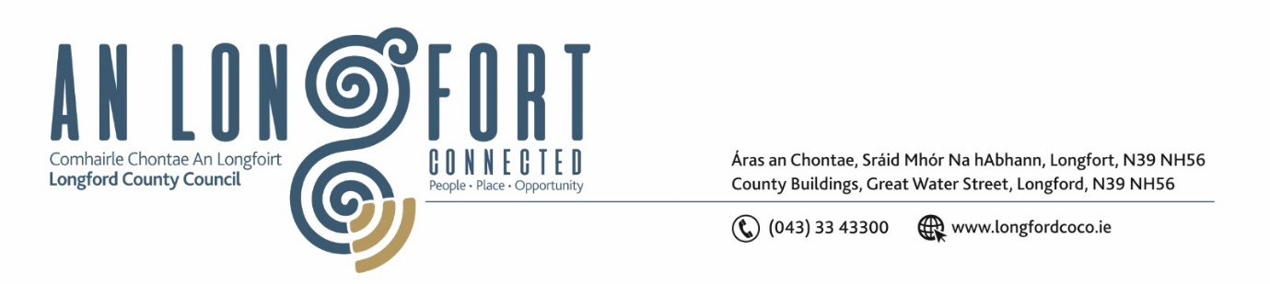

**LONGFORD MUNICIPAL DISTRICT**

***Please note meeting will be held in the Council Chamber, Aras an Chontae and via Microsoft Teams***

**19 November 2024**

**To: Each Member of Longford Municipal District.**

**Dear Member,**

You are requested to attend the Meeting of Longford Municipal District to be held in **the Council Chamber, Aras an Chontae** and **via Microsoft Teams** on **Tuesday, 26 November 2024 at 11 am** to transact business, as set out on the agenda hereunder.

**Yours sincerely**,

_______________

**Claire McNabola**

**Meetings Administrator**

**AGENDA**

Prayer before meeting.

**1.** Confirmation of Minutes:

1. Longford Municipal District Meeting held on 15 October 2024 – enclosed
2. Longford Municipal District Meeting held on 22 October 2024 – enclosed.
3. Longford Municipal District Committee Meeting held on 22 October 2024 - enclosed

**2.** Matters arising from Minutes.

**3.** Declaration of Interest by Members

**4**.Management Report – enclosed

**5.** Twinning Committee

**6**. PART 8 – NO. 122 - N63 Farranyoogan, Longford, Co. Longford

**7**. Notice of Motions set out hereunder

**Councillor Kevin Hussey**

1. I call on Longford County Council to fix the number of lights not working on the canal and to fix the surface walkways where the grass is so badly overgrown.

**Councillor Uruemu Adejinmi**

1. I call on Longford County Council to assess the viability of an improved pedestrian crossing at the head of New Street in Longford Town.
2. I call on Longford County Council to actively engage with the owners of derelict and vacant residential properties within Longford MD to promote the Croí Cónaithe scheme. Furthermore, I urge the Council to explore the option of Compulsory Purchase Orders (CPO) for eligible residential properties, with the aim of making these properties available to first-time homebuyers among the local working population.